NAME: _____________________________
R – E – S – P – E – C – T
(find out what it means to me!)
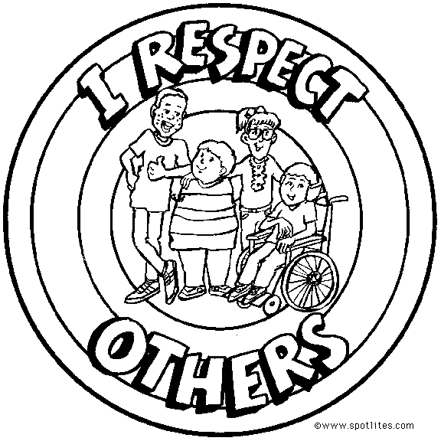
- What does this quote mean to you?

“If you treat an individual…as if he were what he ought to be and could be, he will become what he ought to be and could be.” – Goethe

- Give two examples of people whom YOU KNOW that you respect

- Name: _________________________________

Why? _________________________________

- Name: _________________________________

Why? _________________________________

- In your own words write definitions or words that you think relate to the following terms:

  - Respect

  - Disrespect

OVER

- What are 3 ways to show respect to others? Especially your classmates!

- Tell a story of being disrespected and how it made you feel.

- Tell a story of being respected and how it made you feel.

- What could Mr. Lonsdale do this semester to make you feel respected?

