Part 1: Introduction to Biodiversity
NAME:
Learning Target #2: Given a description of the biodiversity in two ecosystems, identify reasons for differences in biodiversity.
- In your Notebook:
- Read pages 371-372. Look at the map on page 372 (Figure 10 Earth’s Biomes). The biosphere (Earth) is not spread out uniformly around the planet. Looking at Earth from a space shuttle, you would see that the biosphere is “patchy”—like a quilt of different environments, including land and oceans, lakes and ice. Zoom in closer to observe just one continent, and you would see an uneven distribution of ecosystems such as deserts, grasslands, forests, and rivers. A still smaller area, such as a wilderness, may contain patches of woods, fresh water, and marshes. Explain what causes this “patchiness.”
- The organisms found inhabiting a specific ecosystem have adapted to specific abiotic factors. Name 5 important abiotic factors that affect the biodiversity of an area.
- The Earth is heated “unevenly.” What does this mean and what impact does this have on precipitation and the location of specific ecosystems (deserts vs. the tundra)?
- What 2 key abiotic factors have the greatest influence on the Earth’s major
ecosystems?
- Define the term biome using p. 372. Do you think the term biome is used for land or water ecosystems or both?

- Checkpoint: Please have the teacher look over your work and place a stamp on the 5 completed questions

Part 2: Biodiversity of different types of Biomes
Biodiversity refers to the variety of biological species, the genetic differences among them, and the habitats and ecosystems they comprise. A vast diversity of biological species inhabits Earth. Estimates of Earth’s total species diversity range from 10-100 million. Yet, the number of species scientists have actually classified is only 1,413,000. More than 751,000 are insects, and about 248,000 are higher plants. The range of estimates of Earth’s total biodiversity is so broad because we know so little about certain kingdoms of organisms, particularly the Bacteria and Protista. Only about 31,000 protozoa species, 5,000 bacteria species, and 1,000 species of viruses have been classified. Certain ecosystems, such as rain forest canopies and ocean floors, remain relatively unexplored. (NSTA, Biodiversity) In this section, you and a team will investigate the biodiversity of 8 different major ecosystems on Earth.

Research: Form a group of 2-4 students. Use the Biome chart your teacher will hand out to you. Have each member research the characteristics of the 8 Biomes shown on the chart - decide who will research what Biome(s). Be specific when conducting the research. Rather than list just “cactus” for a plant of the desert, use the Internet and/or the textbook (pgs. 373-375) to name a specific type of cactus. Once everyone is done, share what you learned and make additions and/or changes to your work. Study Skills Tip: Everyone in your team needs to learn about the biodiversity and climate of the 8 biomes and will be responsible for this information. Jump into this learning process now! Avoiding it now, will be double the work later in the unit…..
Color the World Map: See page 372 in your book and color in your world map of the biomes. Please color code each biome and make a key in your notebook. Glue the map below the key. Become familiar with the locations of the different biomes around the world and think about why they are located where they are located.

- Checkpoint: Please have the teacher look over your work and place a stamp on the Research and World Map

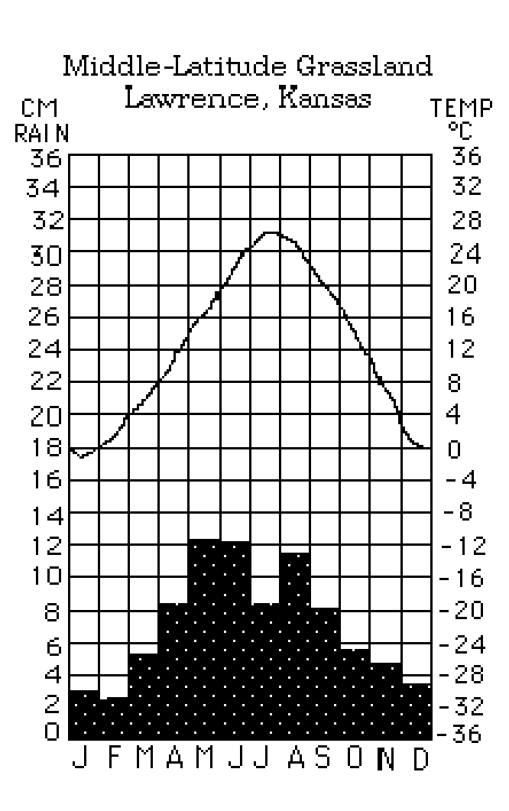
Part 3: Comparing Ecosystems Using Climatograms
Understanding Climatograms for Biomes
- Examine the figure to the right. It is called a climatogram. It shows the monthly variation of temperature and rainfall during an entire year for Lawrence, Kansas.
- Note that the line for temperature corresponds to the degrees listed along the right side of the climatogram. Note that the vertical bar graph for rainfall corresponds to the centimeters listed along the left of the climatogram. The letters along the bottom correspond to the months of the year.
- Examine the prepared climatograms for the terrestrial biomes attached to the back of this packet. Note how the precipitation and temperature patterns vary.
- Use the climatograms to complete the analysis questions below.

Answer the following analysis questions:

- Using your climatograms, describe how the pattern of precipitation differs during the seasons:
  - Between a grassland and a desert
  - Between a grassland and a coniferous forest
Figure 34.5: Mean Annual Precipitation and Temperature in the World’s Biomes
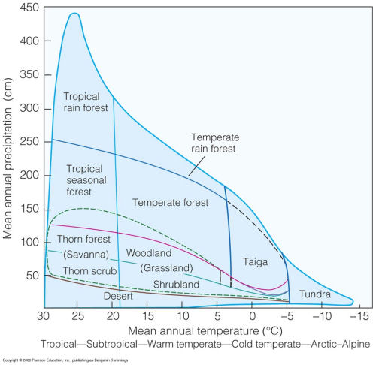
- Make an estimate as to the length of the growing season in months for plants in: [hint: temperatures need to be above 0°C]
  - Tundra
  - Coniferous Forest
  - Tropical Rain Forest
  - Grassland
Which of the above biomes (A-D) would have the greatest amount of vegetation? Explain your reasoning.
- Using Figure 34.5 - Which biome appears to have the:
  - Highest average precipitation? Lowest average precipitation?
  - Highest average temperature? Lowest average temperature?

- In general, how do the biomes change in regard to annual precipitation and temperature as one moves farther north in latitude? (You may want to refer to the biome map that you colored or the textbook book – page 372).
- What biome do you live in?
- Why aren’t grasslands (prairies) located in the Southwest of North America?
- In the desert we find cacti, kangaroo rat and camels; what adaptations make these organisms successful in the desert biome?
- List at least three challenges that organisms in the tundra need to deal with in order to be successful?
- What are the two factors that determine the different biomes?
- If global warming increased the mean annual precipitation in a Temperate Forest biome to 250cm would it still be a Temperate Forest biome? Explain.
- What is the difference between the Coniferous Forest and the Tundra biomes?
- Choose two adjacent biomes (refer to the map to locate two biomes that are next to each other) and compare and contrast in terms of temperature and precipitation.

Part 4. Stability of an ecosystem
Learning Target #3: Describe that biodiversity contributes to the stability of an ecosystem.

Read the following article below. Answer questions as you read through the article:
- How did the amount of biodiversity in the seeded patches of grassland affect the amount of plant life(biomass)? Over what time frame were the studies completed?
- What did David Hooper discover were the main drivers(reasons) for the loss of biodiversity?
- What is one of the reasons humans are impacting the planet? (What do we all need to survive?)
- What elemental cycles are controlled by the Earth’s biodiversity?

How Biodiversity Keeps Earth Alive
By David Biello From Scientific American May 3, 2012

In 1994 biologists seeded patches of grassland in Cedar Creek, Minn. Some plots got as many as 16 species of grasses and other plants—and some as few as one. In the first few years plots with eight or more species fared about as well as those with fewer species, suggesting that a complex mix of species—what is known as biodiversity—didn't affect the amount of a plot's leaf, blade, stem and root (or biomass, as scientists call it). But when measured over a longer span—more than a decade—those plots with the most species produced the greatest abundance of plant life.

"Different species differ in how, when and where they acquire water, nutrients and carbon, and maintain them in the ecosystem. Thus, when many species grow together, they have a wider set of traits that allow them to gain the resources needed," explains ecologist Peter Reich of the University of Minnesota, who led this research to be published in Science on May 4. This result suggests "no level of diversity loss can occur without adverse effects on ecosystem functioning." That is the reverse of what numerous studies had previously found, largely because those studies only looked at short-term outcomes.

The planet as a whole is on the cusp of what some researchers have termed the sixth mass extinction event in the planet's history: the wiping out of plants, animals and all other forms of life due to human activity. The global impact of such biodiversity loss is detailed in a meta-analysis led by biologist David Hooper of Western Washington University. His team examined 192 studies that looked at species richness and its effect on ecosystems. "The primary drivers of biodiversity loss are, in rough order of impact to date: habitat loss, overharvesting, invasive species, pollution and climate change," Hooper explains. Perhaps unsurprisingly, "biodiversity loss in the 21st century could rank among the major drivers of ecosystem change," Hooper and his colleagues wrote in Nature on May 3. (Scientific American is part of Nature Publishing Group.)

Losing just 21 percent of the species in a given ecosystem can reduce the total amount of biomass in that ecosystem by as much as 10 percent—and that's likely to be a conservative estimate. And when more than 40 percent of an ecosystem's species disappear—whether plant, animal, insect, fungi or microbe—the effects can be as significant as those caused by a major drought. Nor does this analysis take into account how species extinction can both be driven by and act in concert with other changes—whether warmer average temperatures or nitrogen pollution. In the real world environmental and biological changes "are likely to be happening at the same time," Hooper admits. "This is a critical need for future research."

The major driver of human impacts on the rest of life on this planet—whether through clearing forests or dumping excess fertilizer on fields—is our need for food. Maintaining high biomass from farming ecosystems, which often emphasize monocultures (single species) while also preserving biodiversity—some species now appear only on farmland—has become a "key issue for sustainability," Hooper notes, "if we're going to grow food for nine billion people on the planet in the next 40 to 50 years."

Over the long term, maintaining soil fertility may require nurturing, creating and sparing plant and microbial diversity. After all, biodiversity itself appears to control the elemental cycles—carbon, nitrogen, water—that allow the planet to support life. Only by acting in conjunction with one another, for example, can a set of grassland plant species maintain healthy levels of nitrogen in both soil and leaf. "As soil fertility increases, this directly boosts biomass production," just as in agriculture, Reich notes. "When we reduce diversity in the landscape—think of a cornfield or a pine plantation or a suburban lawn—we are failing to capitalize on the valuable natural services that biodiversity provides."

At least one of those services is largely unaffected, however, according to Hooper's study—decomposition. Which means the bacteria and fungi will still happily break down whatever plants are left after this sixth extinction. But thousands of unique species have already been lost, most unknown even to science—a rate that could halve the total number of species on the planet by 2100, according to entomologist E. O. Wilson of Harvard University. Ghosts of species past haunt ecosystems worldwide, which have already lost not just one or another type of grass or roundworm but also some of their strength at sustaining life as a whole.

