Environmental Engineering Project
2013
Sarah Newton
Physics
6/3/2013
Background:
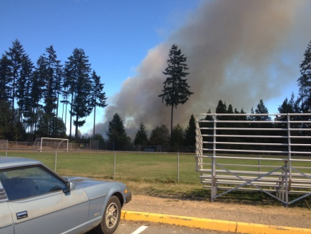
The definition of a climax community, according to dictionary.com, is a stable mature community in a successive series which has reached equilibrium after having evolved through stages and adapted to its environment. This, in teenager terms, means that the community was thriving before the fire and throughout time it has adapted to life. Now it may take a very long time before it can reach the climax community again. Through all of this hardship animals have still come back into the community to thrive. While I was in my one spit spot I saw animals such as Gold Finches, Cliff Swallows, and Mourning Doves. Throughout the burned areas green plants were starting to grow. I saw strawberry plants, lots of green grass, and a variety of ferns. This shows that the burned area is on its way to becoming a climax community. This area is a great opportunity to make the rest of the community “greener”. One thing that we can do is having more recycling options at restaurants and groceries stores. When people are given the opportunity to pick how they throw their trash a way it can change their mind forever. A great example would be Safeco field. They have recycling and compost bins EVERYWHERE. All of their chairs are made out of recycled plastic and they try their hardest to make their stadium as green as possible. We really need t start doing this in the Belfair area.
Problem:
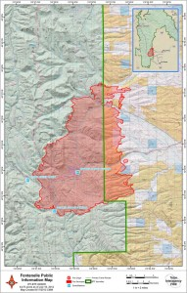
The problem is the burned area behind the school. Thanks to an accidental cigarette dropping, our lovely forested area has been burned. It was contained by the fire department but it still is not a pretty sight. The area is fairly large and is still trying to rejuvenate itself but it is well on its way. Currently small plants are the only ones restoring themselves. Soon, bigger plants such as trees will start growing more vibrantly. Even though this is happening, there is still plenty that needs to be done. One way we can help the rejuvenating process speed up would be to just leave it alone. A great example would be the Fontenelle fire in March. 65,000 acres were burnt and it was a place where 1,200 cattle roamed. After the fire was contained the cattle were not allowed to go back. It wasn’t even a safety hazard at this point but a precaution for the land. If cattle were to be in these lands then the land would not rejuvenate itself. It would become a slow growing land and may never fully recover (Bleizeffer).
How was data collected:
My sit spot was at 47.413 North and -122.837 West. My area was very open but was right in the middle of the burnt area. There were very view plants growing but there were some none the less. I saw grass, a couple of ferns, and even a small strawberry plant. I also saw a few bugs, such as bumble bees, and birds. We had our soot trays sitting on the ground for a couple of days but I didn’t get any foot prints on mine due to some rain. The data I collected is on a huge spreadsheet of data recorded on this url: http://www.arcgis.com/home/webmap/viewer.html?webmap=4d0e6dc5e6024046a4f3cc31178b1530&extent=-122.8448,47.41,-122.8207,47.4179
We also got this cool program that mapped out where our sit spots were. If you follow this link below you can see that map.
http://www.arcgis.com/home/webmap/viewer.html?webmap=4d0e6dc5e6024046a4f3cc31178b1530&extent=-122.8448,47.41,-122.8207,47.4179
This map shows exactly where our sit spots were located and what was seen there. It gives the location and the species name. Had I gotten more time with this program, I think I would have been able to make it more descriptive and in depth. When companies use this program they can use it to map building sites out of if they are an environmental group, they can do exactly what we did and recorded what we saw.
Data Analysis:
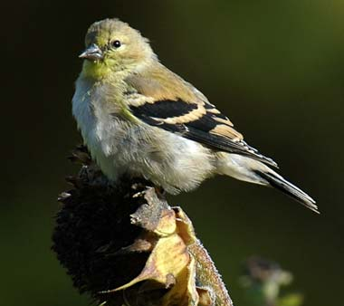
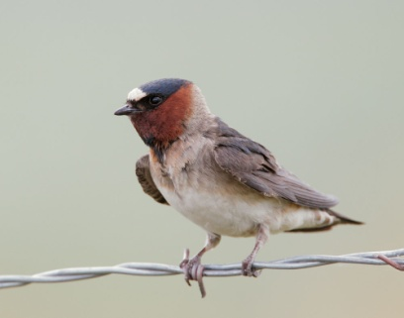
The habitat that I sat in on was mostly dirt and a couple of burnt trees. The species in my area were animals and bugs that could easily move into a different area if they weren’t getting what the needed. These animals included: a cliff swallow, a goldfinch, and a bumble bee. All of these species have wings and have the opportunity to move around. The birds are also animals that have good memories and tend to come back to their home even after it may have been destroyed. I know this thanks to a birds nest at my house. The mama bird was creating its nest and a big windstorm came that night and knocked it down. Luckily there were no baby birds in it at the time but the mama bird kept coming back to the same spot and ended up creating a new nest in the same spot.
I was not the only one to see these types of species either. If you refer back to the link of the data you can also see what the rest of group got in there different sit spots. Some people saw such things as owls, wood peckers, and mourning doves. We even had one person who saw a deer. We are very lucky to be able to see all of these magnificent species. Everyone did have a very different sit spot. Some people were not in as much of a burned area as others were so they saw more vegetation than others as well as some different animals due to the amount of food available. If you look on the GIS map you can see how far some of us were spread out. Some people went really far back into the burned area while others stayed closer to the school.
Proposed Solution:
Through some research I have learned that the best thing to do for the restoration process is to just leave it alone. If people start tampering with the area then nature can’t run its course to restore itself (recovering). It is like a scab. If you keep ripping it off you will end up with a scar. If you just leave it alone then it won’t be a problem and it would heal properly. If we leave the area alone we can watch it grow back to the way it was and maybe even have it look better than it did before hand. Once this process is done we can create a group to keep it looking great and cleaning any trash there maybe. We can also put up signs about wildfire and the consequences of them. As Smokey has always said, “we all can prevent wildfires.” If the area is left alone than species of all kinds can slowly start to flourish today. Animals will come back to thrive and plants will do the same. Plants will start re-growing and the animals will come back to eat those plants. The actions that we have to take are just leaving it alone until it is restored and then we can only prevent this from happening again.
Conclusion:
This project was pretty fun but I wish that I would have had more time with it. I was gone so much that I only had time for one sit spot which didn’t give me a whole lot to work with. I have learned that though this is an environmental disaster, the land will restore itself. I had been doing this more millions of years without our help and can surely do it now with us there to protect it. I also found out that animal species will come back quite quickly. It has been about 6 month and animals are already starting to come back. Students are leaving it alone and so is administration so it has the time to come back to the way it needs to be.
Works Cited
"Climax community - Wikipedia, the free encyclopedia." Wikipedia, the free encyclopedia. N.p., n.d. Web. 6 June 2013. <http://en.wikipedia.org/wiki/Climax_community>.
"Recovering From Wildfire." College of Agriculture and Life Sciences. N.p., n.d. Web. 6 June 2013. <http://cals.arizona.edu/pubs/natresources/az1294/>.
"Restoration or Exploitation?." native Forest. N.p., n.d. Web. 6 June 2013. <www.nativeforest.org/pdf/Bitterroot_Primer.pdf>.
"Secondary succession - Wikipedia, the free encyclopedia." Wikipedia, the free encyclopedia. N.p., n.d. Web. 6 June 2013. <http://en.wikipedia.org/wiki/Secondary_succession>.

