Environmental Engineering Project

Physics B
Environmental Engineering Project
Mr. Lonsdale
North Mason High School
6/6/2013
By Samantha Arkin

Background
In the 2012-2013 the forest surrounding North Mason High School succumbed to a wildfire, this fire burnt about 53,000 square feet of forest next to the softball and baseball fields. Although the fire department was able to contain the fire a large area was burnt to the ground. This burn area was in its finals stage of succession called climax community. Succession is the process of an environment continuously evolving until all the organisms are in complete balance with one another (succession). Before this area was burnt by the fire it was a climax community, so all the plants and wildlife were in balance with each other (climax). The fire disturbed this balance and now the area is forced to rebuild itself. However, some invasive species could hinder the processes of returning to a climax community. Scotch broom is a viciously spreading bush like plant that can interfere with the growth of new plants and trees (Scotch). In the burn area you can still see the burnt scotch broom remains, some still standing and some not. If there are any seeds remaining after the fire this could cause the entire burn area to become a scotch broom forest.
The North Mason community has many habitat restoration programs but the restoration for salmon spawning is one of the projects with the highest involvement. Since Belfair is in the Puget Sound it is important for the community to participate in habits restoration that will have a big impact on the Puget Sound area. One of the more local projects that the community is involved in is the Lower Tahuya River LWD Placement. This is a habitat restoration project that is strategically placing logs in the lower Tahuya River via helicopter in order to create safer, secluded spawning grounds for salmon (Lower). The use of a helicopter as opposed to trucks also prevents damage to the area surrounding the river. In addition to the Lower Tahuya River LWD Placement the community has also recently began a project in Union River Estuary Restoration that will reestablish the salmon habitat in the Union River and surrounding areas (Union). The North Mason community is very aware of the problems occurring in the wildlife that surrounds us, and they are continuously finding safe ways to improve the wildlife habitats in our community.
Problem
After an area of wildlife is affected by a natural disaster such as a burn, flood, or tornado the area needs time to grow back on its own. Unfortunately, this burn area is loomed with the threat of scotch broom taking over, causing the natural habitat for both wildlife and plants to disappear. If the scotch broom was to consume the burn area a sustainable habitat could not grow. As the organisms in the burn area begin to grow back the scotch broom will as well; unlike the trees and grass, the scotch broom viciously spreads. The main issue in the burn area is the threat of an invasive species, such as scotch broom, taking over. However, there is an opportunity to grow a brand new habitat for plants and animals. If the remaining scotch broom was removed from the burn area then the plants and animals currently residing there could be given a chance to, once again, thrive into a climax community because the threat of an overwhelming invasive species would be drastically lessened or even eliminated.
Data Collection
In order to decide how to restore the habitat in the burn area data had to be collected. This data will give and idea of the plants and animals living in the burn area. All students in the Physics B class chose a spot in the burn area (called sit spots) that they would quietly observe the area around them. Each time the student sat in their “sit spot” they would mark down the organisms around them. For example if the saw a spider they would mark one spider, or if they saw a tree stump they would mark one stump. The picture below is an example of the notes chart that each student would fill out.
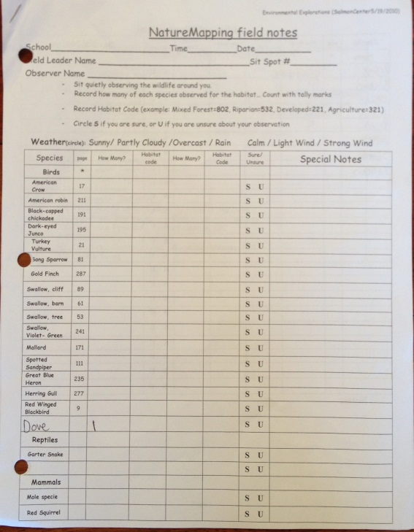
After the information was gathered over the course of about two months the students entered their information into a computer program called Geographic Information Systems, GIS for short. Using the GIS software the student input information into a spread sheet like program, this includes the species type, how many organisms they saw, and the GPS coordinates. After each student entered their information into the program it was compiled into a map of the burn area where students could scroll over the markers and read what organisms reside there.
Data Analysis
Before the fire, the habitat in the burn area flourished with plants and wildlife. It is very evident in the remains to see that many organisms resided here. However that number has drastically decreased since the fire. The data that was collected in the area proves this theory. Colin Ralston, Hector Schope, and CJ Allen’s sit spots were in the same general area they recorded a total of 43 American Robins, 13 American Crows, 1 Dark-eyed Junco, 6 Song Sparrows, 23 Cliff Swallows, 30 Barn Swallows, 5 Tree Swallows, 2 Owls, 6 Hummingbirds, 1 Blue Heron, and 1 Red Squirrel. On the other side of the burn area Sarah Newton, Chanel McGowen, Andi Rasmussen, and I recorded much less wildlife. Between the four of us there were 2 American Crows, 2 Gold Finches, 3 Cliff Swallows, 3 Tree Swallows, 6 Mourning Doves, 1 Woodpecker, and 1 Fly recorded. As you can see the burn areas are vastly different. This is because one area was affected more harshly by the burn that the other. The first area where the wildlife thrived was not as heavily affected as the second area where it was complete scorched. In the figure below you can see the distance between the two areas (about 1,500 feet).
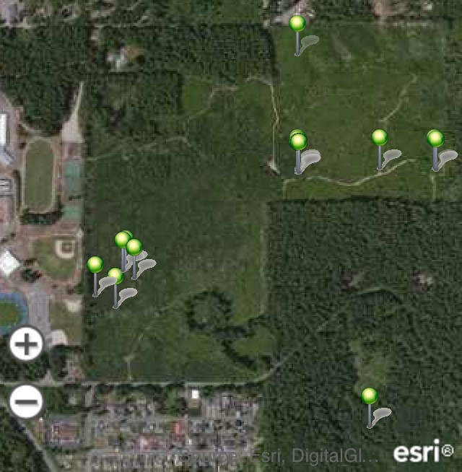
Proposed Solution
When an ecosystem is destroyed due to a natural disaster it is important to let it rebuild itself. Too much human interference could greatly slow down the process of regeneration. That being said, it is acceptable to give it a push in the right direction. First you must observe the area and take all the different species of plants into consideration (Miller). It is important to revegetate the area with plant that are native to that area because it is important to restore the natural habitat not completely change it The Rocky Mountain Field Institute has been restoring huge burn areas in the mountains by repairing damage like trenches and planting native vegetation. The North Mason burn area is a small fraction of the size of the areas in the Rockies but by replanting the indigenous vegetation it could give the ecosystem a jump start and prevent invasive species such as scotch broom (Pikes). The process of replanting this flora is known as revegitation. The North Mason burn area should be treated as if it was just cleared of an invasive species, because in some respects it has. So just like you would revegetate a newly clear area, rapid replantation is necessary. By planting native vegetation and aiding that vegetation in growth all of the natural resources will be used leaving nothing for the invasive species to harvest with (Revegetation). This will prevent the re growth of scotch broom and create a healthy ecosystem.
Conclusion
Although the North Mason burn area is in danger of being overtaken by an invasive species it can definitely be rescued. By replanting the indigenous species of vegetation, the native animals will return and the burn area can be restored to the climax community that it once was.

Works Cited
“climax community” American Heritage Science Dictionary of the English Language. On line. N.p. N.a. 2011. Web. 4 June 2013. <http://ahdictionary.com/word/search.html?q=climax+community>
“Succession” American Heritage Science Dictionary of the English Language. On line. Na. Np. 2011. Web. 4 June 2013. < http://ahdictionary.com/word/search.html?q=succession>
“Scotch Broom” Washington State Noxious Weed Control Board. On Line. Na. Np. 2010 Web. 4 June 2013. < http://www.nwcb.wa.gov/detail.asp?weed=44>
“Lower Tahuya River LWD Placement Phase 2.” Hood Canal Coordinating Council. On line. Na. Np. 31 Oct. 2012 Web. 6 June 2013. <http://hwsconnect.ekosystem.us/Project/170/16815>
“Union River Estuary Restoration.” Hood Canal Coordinating Council. On line. Na. Np. 1 Jan. 2012 Web. 6 June 2013. <http://hwsconnect.ekosystem.us/Project/170/14620>
“Pikes Peak Region” Rocky Mountain Field Institute. On Line. Na. Np. 2013. Web. 4 June 2013
< http://www.rmfi.org/projects/south-platte-hayman-burn-area-restoration-project>
“Revegetation” Integrated Weed Control Project. Washington State University. Na. Np. 2013. Web. 4 June 2013. < http://invasives.wsu.edu/Revegetation.htm>
Miller, Margret M., Miller Joseph W., Suggested Revegetation Practices. Bellvue. Np. June 1977.
Web. 4 June 2013. <http://www.northcascades.org/articles/Miller_Revegetation_Practices.pdf>

